



PROGRAM TITLE: PROGRAMMING

UNIT TITLE: PROGRAMMING

ASSIGNMENT NUMBER: 1

ASSIGNMENT NAME: PROGRAMMING

SUBMISSION DATE: 04/12/2021

DATE RECEIVED: 02/11/2021

TUTORIAL LECTURER: NGUYEN VAN HUY

WORD COUNT: 239

STUDENT NAME: LO VAN HIEN

STUDENT ID: BKC12444

MOBILE NUMBER: 0326660728

|  |
| --- |
| **Summative Feedback:**    **Internal verification:** |

**Table of Contents**

**I. WHAT IS IDE ? 4**

**II. Normal text editor 4**

**III. IDE and Normal text editor 4**

**IV. Debugging support in Eclipse 5**

**1.** **Step One: Set Breakpoints** 5

**2.** **Step Two: Start the Program in Debug Mode** 6

**3.** **Step Three: Add Variables to *Expressions* for Examination** 8

**4.** **Step Four: Check the Variables Values in *Expressions*** 8

**5.** **Step Five: *Step Into* the Function** 8

**6.** **Step Six: *Step Over*** 9

**7.** **Step Seven: Check the Return Value from Function** 9

**8.** **Step Eight: Set Debug Filter** 10

**9.** **Step Nine: Print The Result** 12

**10.** **Step Ten: Stop in Main** 12

**V. Outline the coding standard you have used in your code. 13**

**1.** **organizations to save file name** 13

**2.** **how to organize and name "class", "Method"** 13

**3.** **Variable naming rules** 13

**4.** **Commenting process in the process of writing code** 13

# WHAT IS IDE ?

* an IDE is a handy piece of software that acts as a text editor, debugger, and compiler all in oneDesigned to provide the facilities a programmers needs for software developmentIDE’s provide a text editor, debugger and compiler all in one application.Sometimes these can have more features than we need but are generally designed to make are coding experience as pleasant, customised and quick as possible.
* Popular IDEs today : Netbeans , Eclipse , Visual Studio , Komodo
* IDE function:
* Text editor
* Debugging
* Multiple Plugins Support
* Supports multiple programming languages
* Compile
* Code completion
* Build automation files

# Normal text editor

* Normal text editor is a type of software designed to edit electronic documents
* Normal text editor Function :
* Text editor
* Supports multiple programming

# IDE and Normal text editor

|  |  |  |
| --- | --- | --- |
| Function | IDE | Normal text editor |
| Text editor | Yes | Yes |
| Debugging | Yes | No |
| Multiple Plugins Support | Yes | No |
| Supports multiple programming languages | Yes | Yes |
| Compile | Yes | No |
| Code completion | Yes | No |
| Build automation files | Yes | No |

# Debugging support in Eclipse

Eclipse allows running an application in Debug mode which helps with stepping through each line of code in a program. Eclipse also provides a Debug Perspective which is a set of views grouped together that help inspect code and make the debugging process very effective.

Let’s walk through the steps of debugging a Java application with Eclipse using a simple program, as shown below:

public class EclipseDebuggingExample {

public int add(int a, int b) {

int result = a + b;

return result;

}

public static void main(String[] args) {

EclipseDebuggingExample ede = new EclipseDebuggingExample();

int a = 3;

int b = 7;

int result = ede.add(a, b);

System.out.printf("%d + %d = %d", a, b, result);

}

}

Two simple methods main()andadd()are defined in the above code example. The main() method calls the add() method to add two integers a and b and return their sum. The steps for debugging this program are shown below:

## Step One: Set Breakpoints

A breakpoint is a point in code where the program execution pauses during debugging. This allows the programmer to inspect code and the flow of execution at the defined breakpoint.

To define a breakpoint, either double click on the left margin in the editor or right click and select Toggle Breakpoint:

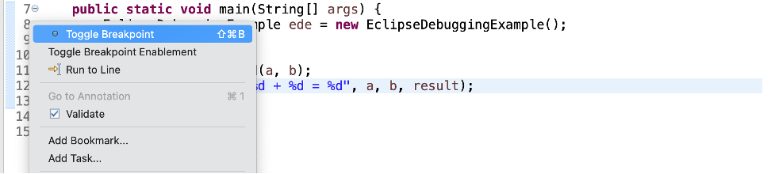

A blue circle should then appear next to the line:

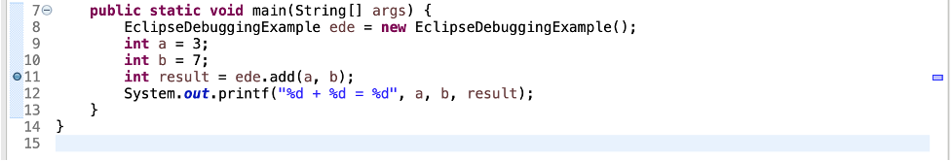

## Step Two: Start the Program in Debug Mode

To debug the application, either right-click on the file in Package Explorer or within the Java editor and select Debug As -> Java Application:

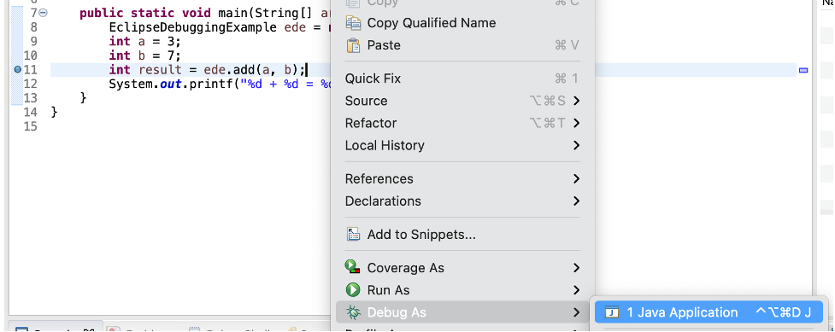

Eclipse asks if you want to switch to the Debug Perspective when a breakpoint is reached:

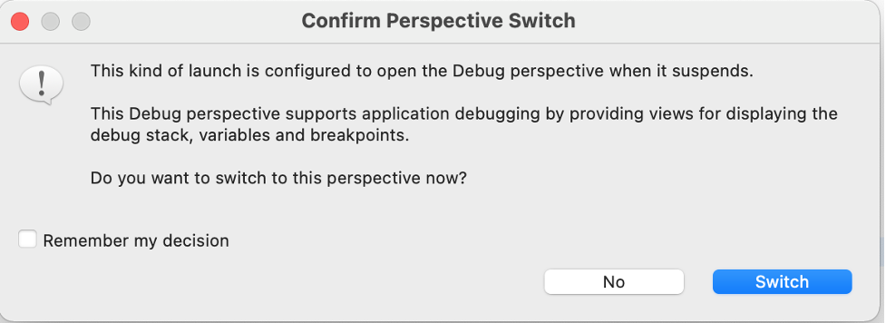

If you click Switch, Eclipse opens this perspective, which has a group of views that help with the debugging process:

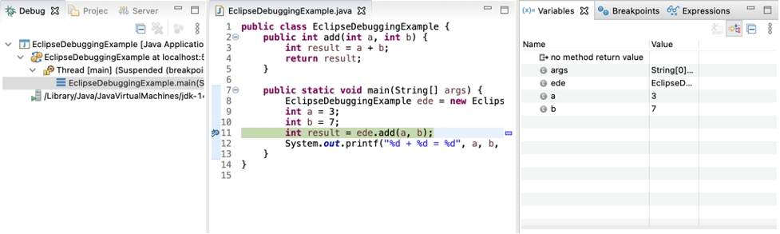

The most commonly used views are described below:

* Debug: Displays the call stack which helps in determining the flow of execution of the program until the breakpoint is reached
* Variables: Displays fields and defined variables in the current stack
* Breakpoints: Shows a list of all breakpoints in the code and enabling/disabling breakpoints
* Expressions: Allows defining custom Java expressions to inspect their values

Eclipse also provides several buttons in the toolbar for controlling the flow of execution of the program:

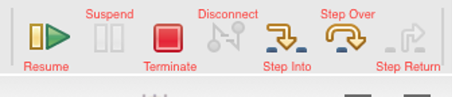

The most commonly used buttons are described below along with their corresponding keyboard shortcuts:

| **Feature** | **Key** | **Description** |
| --- | --- | --- |
| Resume | F8 | Resumes normal execution of the program until the next breakpoint is reached. |
| Step Into | F5 | Executes the current line of code and dives into the next line of code in the program execution. If the current line calls a method, the debugger steps into the method. |
| Step Over | F6 | Executes the current line of code and goes to the next line without stepping into any method calls or associated scope (e.g. loops and conditions) of the current line. |
| Step Return | F7 | Steps back out of the current method and returns to the caller of the method |

## Step Three: Add Variables to Expressions for Examination

Any custom Java expressions (including variables) and their values can be inspected in the Expressions view. For example, to track the value of the a, b and the result variables, they can be added to the Expressions view by right-clicking on each and then clicking Watch:

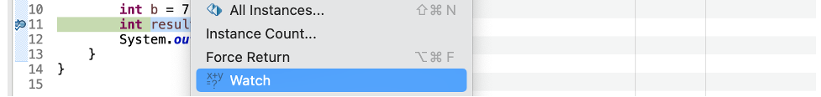

## Step Four: Check the Variables Values in Expressions

The variables are now visible in the Expressions view:

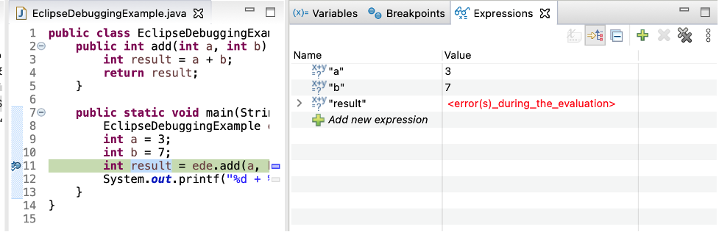

The a and b variables show their correct value in the Expressions view. However, since the result variable isn’t declared at this point, it shows an error in the Value column. This should show a proper value after the current line of code is executed.

## Step Five: Step Into the Function

Press F5 or the Step Into icon to enter into the add method:

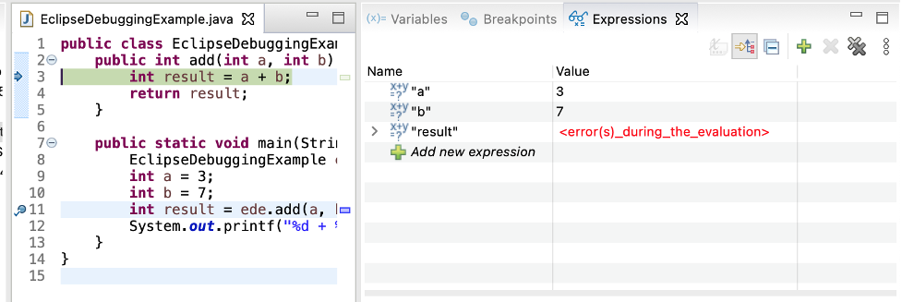

## Step Six: Step Over

Press F6 or the Step Over icon to execute the current line of code and go to the next one:

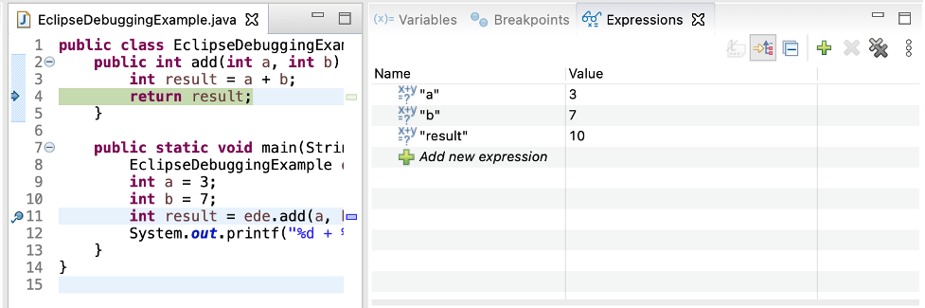

As seen in the image above, the result variable evaluates as expected.

## Step Seven: Check the Return Value from Function

Press Step Over again to return to the main() method:

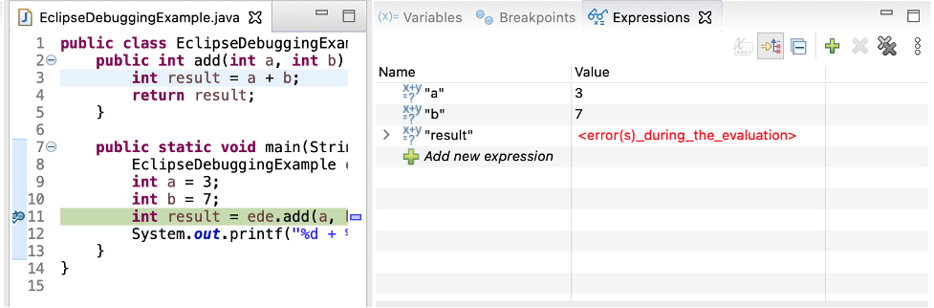

The debugger returns to stop on the same line where it left previously in Step 5. Press Step Over again to check the return value from the add() method:

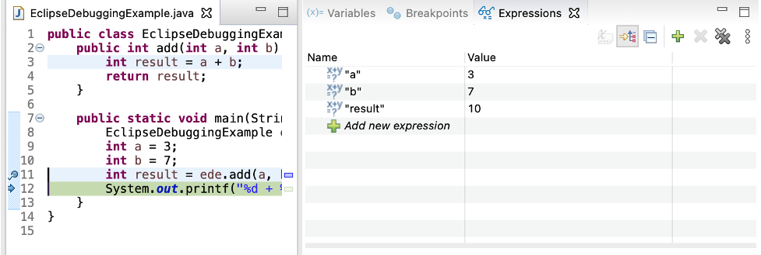

As expected, the result variable evaluates correctly to the value returned by the add() method.

## Step Eight: Set Debug Filter

At this point, if you press Step Into (F5), the debugger will dive into the Java.lang.Integer class:

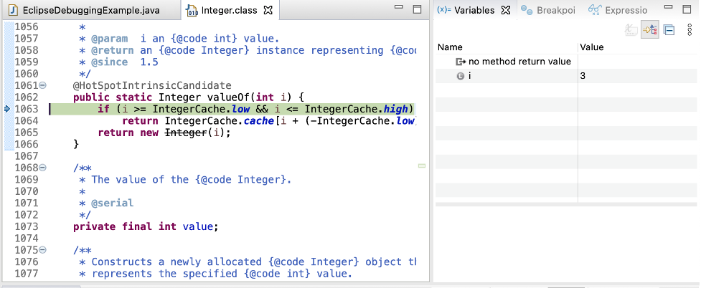

Because line 12 in the EclipseDebuggingExample class is trying to print out the value of an integer, it calls the valueOf method in the Java.lang.Integer class and the debugger dives in there.

This can be avoided by creating a Step Filter using the following steps:

* In the Debug view, right-click on any item in the pane that contains the daemon thread and select Edit Step Filters:

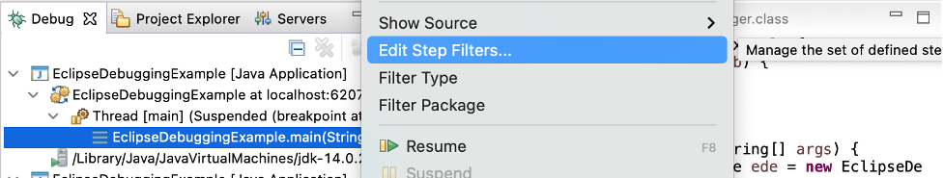

* In the popup window, check the Use Step Filters box. Enable the packages that you want to filter out and press Apply and Close:

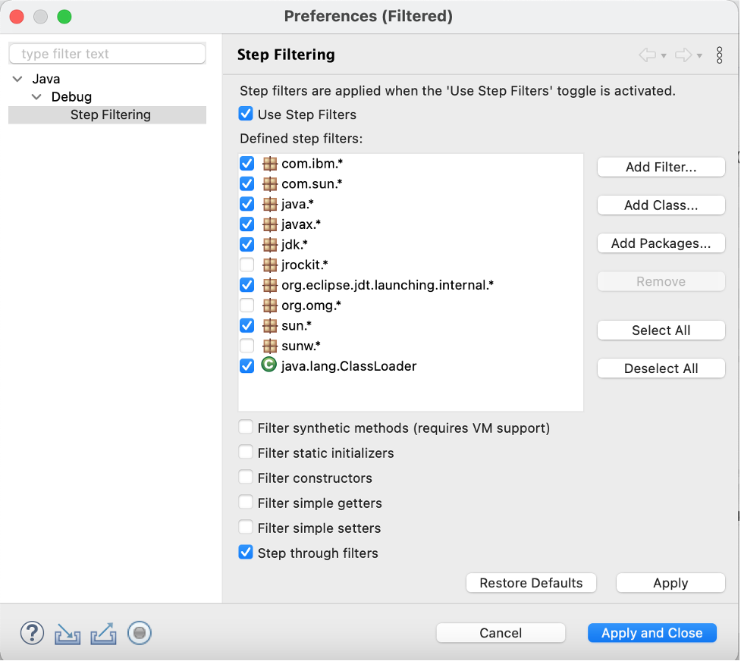

* Now when you press Step Into, it will no longer go to the Integer.class code:

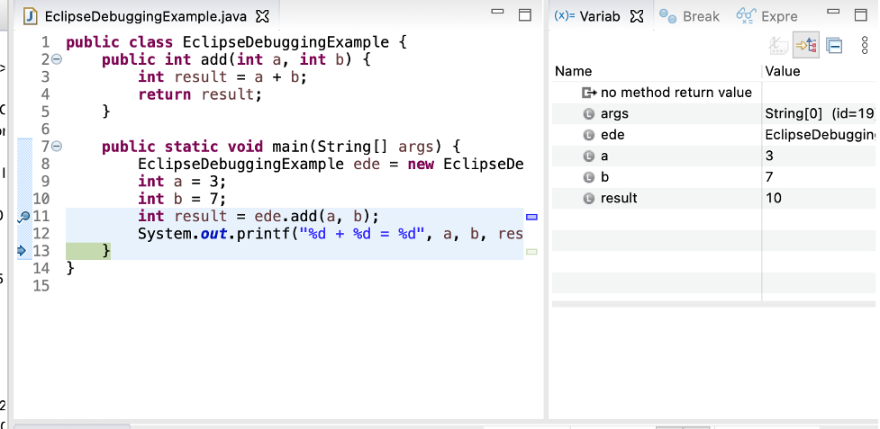

## Step Nine: Print The Result

At this point, line 12 executes and prints the result to the Console successfully:

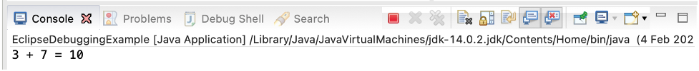

## Step Ten: Stop in Main

The debugger can now be stopped by pressing the Terminate icon in the toolbar:

java program terminated in eclipse

The debugger will now be disconnected:

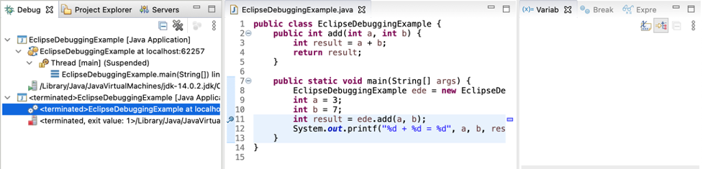

# Outline the coding standard you have used in your code.

## organizations to save file name

* The first letter of the file name is always capitalized
* Use "_" instead of "Space"
* Rules for folders : divided into 3 main folders
* folder "App" contains class "Main" to run the program
* folder "Models" contains class"Book Info" which is the information frame
* The "Services" folder contains the "Book_Management" class for managing books and the "Tools" class for the filter

## how to organize and name "class", "Method"

* Class
* The first letter of the class name is always capitalized
* Use "_" instead of "Space"
* set name for class to run the program is "Main"
* The class that configures the book information is "Book_info"
* class name for book management is "Book_Management"
* name the filter class "Tools"
* Method
* The first letter of the Method name is always capitalized
* Use "_" instead of "Space"
* Name the method the same as the function it needs to perform

## Variable naming rules

* Set the name variable same with function of it
* the first variable letter is always capitalized
* Use "_" instead of "Space"

## Commenting process in the process of writing code

* comment on all the "Methods" and the places that need to be noted
* Comment 1 line, use "//"
* Comment Multi-line , use "/** */"